STEREO HEADSET
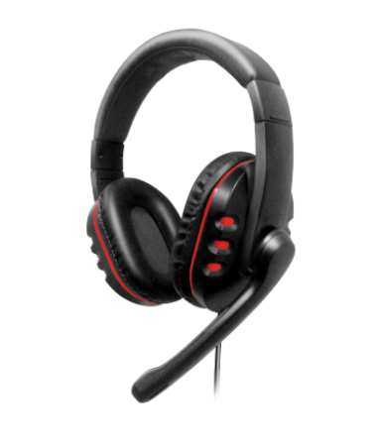
MX-878

Descrption:
Who's you're Nemesis ?

The Dynamode Nemesis MX-878 integrates stereo game sound with crystal-clear communication on the PC/Mac to create the absolute audio environment regardless of whether you are playing popular game titles or just using them on your mobile phone or music player (Cable Convertor Included). The Dynamode Nemesis MX-878 is a stereo USB headset for the everyday / adept gamer allowing you to enjoy great sounding games and communicating with your friends & foes via the adjustable microphone.
The Dynamode Nemesis MX-878 comes with large, leather ear cups and an ergonomic adjustable headband designed to provide comfort during extended game play.
It features convenient volume controls for chat and game audio provided by the inline remote which allows you to mute the microphone at will and enables you to change the volume on the spur.
Gain the competitive edge in game... as the Dynamode Nemesis MX-878 is the difference between winning and losing, let the MX make sure you are somebody's Nemesis.

SPEZIFIKATION:
- Frequency Range:20Hz- 20KHz
- Impedance:32 Ohm
- Maximum Power Input:100mw
- Sensitivity:105dB S.P.L. at 1KHz+/-2%
- Frequency Range:16Hz- 20KHz
- Impedance:2.0K 0hm
- Maximum Power Input:0.4ma
- Sensitivity:-55dB, 0dB=1V/Pa at1 Khz

